Operation Analytics and Investigating Metric Spike

By: Abhijit Mandape

**Project Description**

* The project is a collection two used cases for Operation Analytics and Investigating Metric Spike

**Approach**

* For Case 1:
  + The given dataset is created using the SQL syntax using the MYSQL workbench.
  + The data contained within the tables was explored.
* For Case 2:
  + A separate schema was created and the data in CSV files were uploaded using the option “Table Data Import Wizard” in the MYSQL workbench.
  + The data contained within the tables and the connection between them was explored.

**Tech-Stack Used**

* MYSQL Workbench 8.0.33 for writing SQL queries.
* XAMPP Control Panel v 3.3.0 for creating local server.

**Insights**

* The clauses “COUNT”, “SUM”, “DATE”, “CASE”, were explored.
* Advanced JOINS and subquery implementation gave a good understanding of how more refined output can be obtained.

**Result**

* The project helped to learn and practice advanced topics like JOINS, subqueries, and complex calculations using the arithmetic operators.
* Exploring the use of “Table Data Import Wizard” gave insights on how easily to import large data sets without typing the contents manually with sql query.

**Case Study 1 (Job Data)**

Query to create table:

CREATE DATABASE holadb;

USE holadb;

CREATE TABLE job_data(

job_id INT,

actor_id INT,

even_t VARCHAR(20),

lan_guage VARCHAR(10),

time_spent VARCHAR(5),

org VARCHAR(20),

ds DATETIME);

INSERT INTO job_data VALUES (21, 1001, "skip", "English", 15, "A", "2020-11-30"),

(22,1006, "transfer", "Arabic", 25, "A", "2020-11-30"),

(23,1003, "decision", "Persian", 20, "C", "2020-11-29"),

(23,1005, "transfer", "Persian", 22, "D", "2020-11-28"),

(25,1002, "decision", "Hindi", 11, "B", "2020-11-28"),

(11,1007, "decision", "French", 104, "D", "2020-11-27"),

(23,1004, "skip", "Persian", 56, "A", "2020-11-26" ),

(20,1003, "transfer", "Italian", 45, "C", "2020-11-25");

SELECT * FROM job_data;

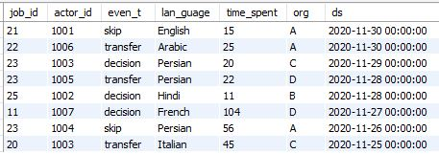

1. **Number of jobs reviewed:** Amount of jobs reviewed over time.   
   **Your task:** Calculate the number of jobs reviewed per hour per day for November 2020?

SQL query:

SELECT DATE(ds) AS 'date', ROUND((COUNT(job_id)/(SUM(time_spent/60)))) AS

job_viewed_per_hour_per_day

FROM job_data

WHERE ds BETWEEN '2020-11-01' AND '2020-11-31'

GROUP BY ds;

Output:

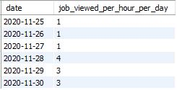

1. **Throughput:** It is the no. of events happening per second.   
   **Your task:** Let’s say the above metric is called throughput. Calculate 7 day rolling average of throughput? For throughput, do you prefer daily metric or 7-day rolling and why?

Sql Query:

SELECT date, job_viewed_hours_per_day,

AVG(job_viewed_hours_per_day) OVER (PARTITION BY date) AS

rolling_average_throughput

FROM (SELECT DATE(ds) AS 'date', ROUND(COUNT(job_id)/SUM(time_spent/60))

AS job_viewed_hours_per_day

FROM job_data

WHERE ds BETWEEN '2020-11-01' AND '2020-11-31'

GROUP BY ds) AS throughput;

Output:

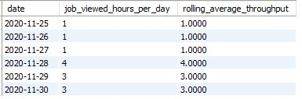

1. **Percentage share of each language:** Share of each language for different contents.   
   **Your task:** Calculate the percentage share of each language in the last 30 days?

SQL query:

SELECT DATE(ds) AS date, lan_guage, SUM(time_spent) AS total_time_mins,

COUNT(job_id) AS job_count, count(job_id)*100 / sum(count(*)) OVER() AS percentage_share

FROM job_data

WHERE ds BETWEEN '2020-11-01' AND '2020-11-31'

GROUP BY lan_guage

ORDER BY ds;

Output:

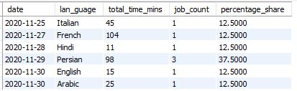

1. **Duplicate rows:** Rows that have the same value present in them.   
   **Your task:** Let’s say you see some duplicate rows in the data. How will you display duplicates from the table?

SQL query:

SELECT ds, job_id, actor_id, even_t, lan_guage, time_spent, org,

CASE WHEN COUNT(*) > 1 THEN 'Duplicate' ELSE 'No Duplicate' END AS Duplicate

FROM job_data

GROUP BY ds, job_id, actor_id, even_t, lan_guage, time_spent, org;

Output:

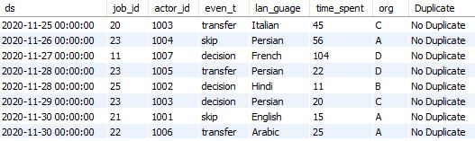

###### Case Study 2 (Investigating metric spike)

1. **User Engagement:** To measure the activeness of a user. Measuring if the user finds quality in a product/service.   
   **Your task:** Calculate the weekly user engagement?

SQL query:

SELECT WEEK(occurred_at) AS week, COUNT(DISTINCT user_id) AS user_engagement

FROM events

GROUP BY week;

Output:

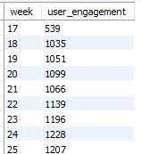

1. **User Growth:** Amount of users growing over time for a product.   
   **Your task:** Calculate the user growth for product?

SQL query:

SELECT DATE(created_at) AS date, COUNT(*) AS user_count,

COUNT(*) - (SELECT COUNT(*)

FROM users AS prev

WHERE DATE(prev.created_at) < DATE(curr.created_at)) AS

user_growth

FROM users AS curr

GROUP BY DATE(created_at)

ORDER BY DATE(created_at);

Output:

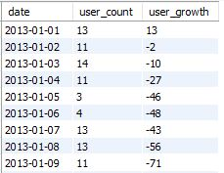

1. **Weekly Retention:** Users getting retained weekly after signing-up for a product.   
   **Your task:** Calculate the weekly retention of users-sign up cohort?

SQL query:

Step 1: Identify the sign-up cohort for a specific week

SELECT WEEK(created_at) AS cohort_week, COUNT(DISTINCT user_id) AS cohort_size

FROM users

GROUP BY cohort_week

ORDER BY cohort_week;

Output:

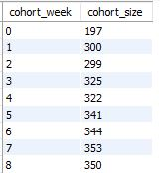

Step 2: Calculate the weekly retention for each subsequent week

SELECT cohort_week, retention_week, COUNT(DISTINCT user_id) AS retained_users,

COUNT(DISTINCT user_id) / (SELECT COUNT(DISTINCT user_id)

FROM users WHERE WEEK(created_at) = cohort_week) * 100 AS retention_rate

FROM (SELECT WEEK(u.created_at) AS cohort_week, WEEK(e.occurred_at) AS

retention_week, u.user_id

FROM users u

INNER JOIN events e ON u.user_id = e.user_id

WHERE e.occurred_at > u.created_at

GROUP BY cohort_week, retention_week, u.user_id) AS retention_data

GROUP BY cohort_week, retention_week

ORDER BY cohort_week, retention_week;

1. **Weekly Engagement:** To measure the activeness of a user. Measuring if the user finds quality in a product/service weekly.   
   **Your task:** Calculate the weekly engagement per device?

SQL query:

SELECT YEARWEEK(occurred_at) AS week, device, COUNT(*) AS engagement_count

FROM events

GROUP BY YEARWEEK(occurred_at), device

ORDER BY week, device;

Output:

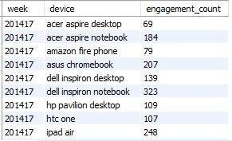

1. **Email Engagement:** Users engaging with the email service.   
   **Your task:** Calculate the email engagement metrics?

SQL Query:

SELECT WEEK(occurred_at) AS week,

COUNT(DISTINCT CASE WHEN action = 'email_open' THEN user_id END) AS

unique_users_email_opened,

COUNT(DISTINCT CASE WHEN action = 'email_clickthrough' THEN user_id END) AS

unique_users_email_clicked,

COUNT(DISTINCT CASE WHEN action = 'sent_weekly_digest' THEN user_id END) AS

unique_sent_weekly_digest,

COUNT(DISTINCT CASE WHEN action = 'sent_reengagement_email' THEN user_id END)

AS unique_sent_reengagement_email

FROM email_events

GROUP BY week(occurred_at)

ORDER BY week(occurred_at);

Output:

